Students Stress and Well Being Survey Analysis
Table of contents
1. Results 1
2. Table 1 – Demographic characteristics of survey respondents 1
3. Table 2 – Likert Scale Characteristics of respondents 1
4. Table 3 - Characteristics of all Respondents. 1
5. Pre defined factors 1
6. Factor Analysis 1
7. Reevaluate Reliability - cross check 1
8. Recalculating Scores for the new subscales /factors in the dataset 1
9. Score Distribution 1
10. Score Distribution - Extreme outlier removal 1
11. Linear Regression - Satisfaction Score 1
12. Assumptions 1
13. Reporting Beta table 1
14. Reporting ANOVA Table 1
15. R package References 1
16. References 1

1. Results
The dataset was downloaded from Kaggle (1) using the url: https://www.kaggle.com/datasets/ashutoshsingh22102/stress-and-well-being-data-of-college-students/data

2. Table 1 – Demographic characteristics of survey respondents
Characteristic | Negative Stress  N = 32¹ | No Stress  N = 43¹ | Positive Stress  N = 768¹
gender_recode
Female | 13 (40.6%) | 20 (46.5%) | 262 (34.1%)
Male | 19 (59.4%) | 23 (53.5%) | 506 (65.9%)
age
Mean (SD) | 20.6 (3.3) | 19.3 (3.7) | 20.1 (5.6)
age_category
10-19 years | 11 (34.4%) | 31 (72.1%) | 390 (50.8%)
100-109 years | 0 (0.0%) | 0 (0.0%) | 3 (0.4%)
20-29 years | 20 (62.5%) | 11 (25.6%) | 364 (47.4%)
30-39 years | 1 (3.1%) | 0 (0.0%) | 9 (1.2%)
40-49 years | 0 (0.0%) | 1 (2.3%) | 2 (0.3%)
¹n (%)

3. Table 2 – Likert Scale Characteristics of respondents
 | Response
 | Not at all | Slightly | Moderately | Very | Extremely
Likert Item
have_you_recently_experienced_stress_in_your_life | 78 (9.3%) | 219 (26%) | 263 (31%) | 193 (23%) | 90 (11%)
have_you_noticed_a_rapid_heartbeat_or_palpitations | 106 (13%) | 282 (33%) | 222 (26%) | 178 (21%) | 55 (6.5%)
have_you_been_dealing_with_anxiety_or_tension_recently | 193 (23%) | 247 (29%) | 217 (26%) | 124 (15%) | 62 (7.4%)
do_you_face_any_sleep_problems_or_difficulties_falling_asleep | 158 (19%) | 215 (26%) | 215 (26%) | 159 (19%) | 96 (11%)
have_you_been_dealing_with_anxiety_or_tension_recently_1 | 177 (21%) | 250 (30%) | 180 (21%) | 152 (18%) | 84 (10.0%)
have_you_been_getting_headaches_more_often_than_usual | 190 (23%) | 234 (28%) | 204 (24%) | 129 (15%) | 86 (10%)
do_you_get_irritated_easily | 203 (24%) | 186 (22%) | 208 (25%) | 151 (18%) | 95 (11%)
do_you_have_trouble_concentrating_on_your_academic_tasks | 197 (23%) | 198 (23%) | 211 (25%) | 135 (16%) | 102 (12%)
have_you_been_feeling_sadness_or_low_mood | 186 (22%) | 253 (30%) | 206 (24%) | 121 (14%) | 77 (9.1%)
have_you_been_experiencing_any_illness_or_health_issues | 218 (26%) | 207 (25%) | 232 (28%) | 109 (13%) | 77 (9.1%)
do_you_often_feel_lonely_or_isolated | 232 (28%) | 222 (26%) | 194 (23%) | 128 (15%) | 67 (7.9%)
do_you_feel_overwhelmed_with_your_academic_workload | 237 (28%) | 198 (23%) | 216 (26%) | 130 (15%) | 62 (7.4%)
are_you_in_competition_with_your_peers_and_does_it_affect_you | 207 (25%) | 262 (31%) | 202 (24%) | 102 (12%) | 70 (8.3%)
do_you_find_that_your_relationship_often_causes_you_stress | 219 (26%) | 223 (26%) | 222 (26%) | 106 (13%) | 73 (8.7%)
are_you_facing_any_difficulties_with_your_professors_or_instructors | 216 (26%) | 252 (30%) | 221 (26%) | 90 (11%) | 64 (7.6%)
is_your_working_environment_unpleasant_or_stressful | 206 (24%) | 249 (30%) | 219 (26%) | 108 (13%) | 61 (7.2%)
do_you_struggle_to_find_time_for_relaxation_and_leisure_activities | 220 (26%) | 224 (27%) | 215 (26%) | 111 (13%) | 73 (8.7%)
is_your_hostel_or_home_environment_causing_you_difficulties | 242 (29%) | 247 (29%) | 182 (22%) | 98 (12%) | 74 (8.8%)
do_you_lack_confidence_in_your_academic_performance | 220 (26%) | 200 (24%) | 225 (27%) | 109 (13%) | 89 (11%)
do_you_lack_confidence_in_your_choice_of_academic_subjects | 205 (24%) | 209 (25%) | 211 (25%) | 119 (14%) | 99 (12%)
academic_and_extracurricular_activities_conflicting_for_you | 157 (19%) | 234 (28%) | 203 (24%) | 155 (18%) | 94 (11%)
do_you_attend_classes_regularly | 85 (10%) | 135 (16%) | 238 (28%) | 247 (29%) | 138 (16%)
have_you_gained_lost_weight | 194 (23%) | 300 (36%) | 213 (25%) | 91 (11%) | 45 (5.3%)

4. Table 3 - Characteristics of all Respondents.
A stress score was created based on all questions. The overall reliability was found to be 0.7, which is acceptable by standard convention.
In smc, smcs < 0 were set to .0
In smc, smcs < 0 were set to .0
Variable | V1
raw_alpha | 0.70
std.alpha | 0.75
G6(smc) | 0.78
average_r | 0.11
S/N | 3.05
ase | 0.00
mean | 5.04
sd | 0.85
median_r | 0.08
In smc, smcs < 0 were set to .0
In smc, smcs < 0 were set to .0
Variable | n | raw.r | std.r | r.cor | r.drop | mean | sd
have_you_recently_experienced_stress_in_your_life | 843.00 | 0.32 | 0.33 | 0.28 | 0.27 | 3.00 | 1.13
have_you_noticed_a_rapid_heartbeat_or_palpitations | 843.00 | 0.35 | 0.36 | 0.32 | 0.30 | 2.76 | 1.12
have_you_been_dealing_with_anxiety_or_tension_recently | 843.00 | 0.34 | 0.35 | 0.29 | 0.29 | 2.54 | 1.20
do_you_face_any_sleep_problems_or_difficulties_falling_asleep | 843.00 | 0.33 | 0.33 | 0.28 | 0.27 | 2.79 | 1.27
have_you_been_dealing_with_anxiety_or_tension_recently_1 | 843.00 | 0.39 | 0.38 | 0.34 | 0.33 | 2.66 | 1.27
have_you_been_getting_headaches_more_often_than_usual | 843.00 | 0.38 | 0.38 | 0.34 | 0.33 | 2.63 | 1.27
do_you_get_irritated_easily | 843.00 | 0.36 | 0.35 | 0.31 | 0.31 | 2.70 | 1.31
do_you_have_trouble_concentrating_on_your_academic_tasks | 843.00 | 0.38 | 0.37 | 0.33 | 0.33 | 2.70 | 1.31
have_you_been_feeling_sadness_or_low_mood | 843.00 | 0.38 | 0.38 | 0.33 | 0.33 | 2.58 | 1.23
have_you_been_experiencing_any_illness_or_health_issues | 843.00 | 0.42 | 0.42 | 0.38 | 0.37 | 2.55 | 1.25
do_you_often_feel_lonely_or_isolated | 843.00 | 0.39 | 0.39 | 0.34 | 0.34 | 2.50 | 1.26
do_you_feel_overwhelmed_with_your_academic_workload | 843.00 | 0.37 | 0.37 | 0.32 | 0.32 | 2.50 | 1.25
are_you_in_competition_with_your_peers_and_does_it_affect_you | 843.00 | 0.45 | 0.45 | 0.42 | 0.40 | 2.49 | 1.22
do_you_find_that_your_relationship_often_causes_you_stress | 843.00 | 0.35 | 0.35 | 0.29 | 0.29 | 2.51 | 1.24
are_you_facing_any_difficulties_with_your_professors_or_instructors | 843.00 | 0.32 | 0.32 | 0.27 | 0.26 | 2.45 | 1.20
is_your_working_environment_unpleasant_or_stressful | 843.00 | 0.37 | 0.37 | 0.33 | 0.32 | 2.49 | 1.20
do_you_struggle_to_find_time_for_relaxation_and_leisure_activities | 843.00 | 0.38 | 0.38 | 0.33 | 0.33 | 2.52 | 1.25
is_your_hostel_or_home_environment_causing_you_difficulties | 843.00 | 0.37 | 0.37 | 0.32 | 0.32 | 2.42 | 1.26
do_you_lack_confidence_in_your_academic_performance | 843.00 | 0.39 | 0.38 | 0.34 | 0.33 | 2.58 | 1.29
do_you_lack_confidence_in_your_choice_of_academic_subjects | 843.00 | 0.42 | 0.41 | 0.37 | 0.36 | 2.64 | 1.31
academic_and_extracurricular_activities_conflicting_for_you | 843.00 | 0.31 | 0.31 | 0.26 | 0.26 | 2.76 | 1.26
do_you_attend_classes_regularly | 843.00 | 0.25 | 0.26 | 0.18 | 0.20 | 3.26 | 1.20
have_you_gained_lost_weight | 843.00 | 0.26 | 0.27 | 0.20 | 0.21 | 2.40 | 1.11
score | 843.00 | 1.00 | 1.00 | 1.01 | 1.00 | 60.40 | 10.30

5. Pre defined factors
The reliability of the groups of indicators, stated in another study (5) were assessed. These included: - Emotional and Stress Indicators - Physical and Health Indicators - Academic & Environment Stressors - Social & Relationship Factors
factors | raw_alpha
emotional_stress | 0.54
physical_health | 0.23
academic_environment | 0.59
social_relationships | 0.22
Some of the categories, have low reliability, less than 0.7.

6. Factor Analysis
Factor Analysis was then used to see if there were other subscales / groups of questions corresponding to themes.
Kaiser-Meyer-Olkin factor adequacy
Call: KMO(r = fa_data)
Overall MSA = 0.71
MSA for each item =
have_you_recently_experienced_stress_in_your_life
0.63
have_you_noticed_a_rapid_heartbeat_or_palpitations
0.63
have_you_been_dealing_with_anxiety_or_tension_recently
0.76
do_you_face_any_sleep_problems_or_difficulties_falling_asleep
0.66
have_you_been_dealing_with_anxiety_or_tension_recently_1
0.69
have_you_been_getting_headaches_more_often_than_usual
0.74
do_you_get_irritated_easily
0.70
do_you_have_trouble_concentrating_on_your_academic_tasks
0.71
have_you_been_feeling_sadness_or_low_mood
0.75
have_you_been_experiencing_any_illness_or_health_issues
0.77
do_you_often_feel_lonely_or_isolated
0.78
do_you_feel_overwhelmed_with_your_academic_workload
0.74
are_you_in_competition_with_your_peers_and_does_it_affect_you
0.77
do_you_find_that_your_relationship_often_causes_you_stress
0.74
are_you_facing_any_difficulties_with_your_professors_or_instructors
0.73
is_your_working_environment_unpleasant_or_stressful
0.73
do_you_struggle_to_find_time_for_relaxation_and_leisure_activities
0.78
is_your_hostel_or_home_environment_causing_you_difficulties
0.68
do_you_lack_confidence_in_your_academic_performance
0.65
do_you_lack_confidence_in_your_choice_of_academic_subjects
0.70
academic_and_extracurricular_activities_conflicting_for_you
0.62
do_you_attend_classes_regularly
0.70
have_you_gained_lost_weight
0.67
R was not square, finding R from data
[1] 0
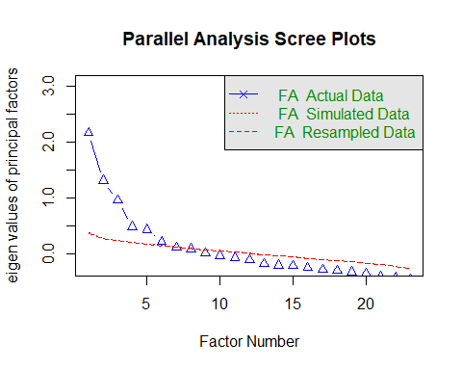
Parallel analysis suggests that the number of factors = 6 and the number of components = NA
Factor Analysis using method = pa
Call: fa(r = fa_data, nfactors = 6, rotate = "varimax", fm = "pa")
Standardized loadings (pattern matrix) based upon correlation matrix
item PA2
is_your_working_environment_unpleasant_or_stressful 16 0.56
are_you_facing_any_difficulties_with_your_professors_or_instructors 15 0.52
are_you_in_competition_with_your_peers_and_does_it_affect_you 13 0.50
do_you_feel_overwhelmed_with_your_academic_workload 12 0.47
do_you_struggle_to_find_time_for_relaxation_and_leisure_activities 17 0.41
do_you_often_feel_lonely_or_isolated 11 0.41
do_you_find_that_your_relationship_often_causes_you_stress 14 0.37
do_you_have_trouble_concentrating_on_your_academic_tasks 8
do_you_get_irritated_easily 7
have_you_been_feeling_sadness_or_low_mood 9
have_you_been_getting_headaches_more_often_than_usual 6
have_you_been_experiencing_any_illness_or_health_issues 10
have_you_noticed_a_rapid_heartbeat_or_palpitations 2
have_you_recently_experienced_stress_in_your_life 1
have_you_been_dealing_with_anxiety_or_tension_recently 3
have_you_been_dealing_with_anxiety_or_tension_recently_1 5
do_you_face_any_sleep_problems_or_difficulties_falling_asleep 4
academic_and_extracurricular_activities_conflicting_for_you 21
do_you_lack_confidence_in_your_choice_of_academic_subjects 20
do_you_attend_classes_regularly 22
have_you_gained_lost_weight 23
do_you_lack_confidence_in_your_academic_performance 19
is_your_hostel_or_home_environment_causing_you_difficulties 18
PA1 PA3
is_your_working_environment_unpleasant_or_stressful
are_you_facing_any_difficulties_with_your_professors_or_instructors
are_you_in_competition_with_your_peers_and_does_it_affect_you
do_you_feel_overwhelmed_with_your_academic_workload
do_you_struggle_to_find_time_for_relaxation_and_leisure_activities
do_you_often_feel_lonely_or_isolated
do_you_find_that_your_relationship_often_causes_you_stress
do_you_have_trouble_concentrating_on_your_academic_tasks 0.60
do_you_get_irritated_easily 0.55
have_you_been_feeling_sadness_or_low_mood 0.55
have_you_been_getting_headaches_more_often_than_usual 0.44
have_you_been_experiencing_any_illness_or_health_issues 0.37
have_you_noticed_a_rapid_heartbeat_or_palpitations 0.66
have_you_recently_experienced_stress_in_your_life 0.62
have_you_been_dealing_with_anxiety_or_tension_recently 0.34
have_you_been_dealing_with_anxiety_or_tension_recently_1
do_you_face_any_sleep_problems_or_difficulties_falling_asleep
academic_and_extracurricular_activities_conflicting_for_you
do_you_lack_confidence_in_your_choice_of_academic_subjects
do_you_attend_classes_regularly
have_you_gained_lost_weight
do_you_lack_confidence_in_your_academic_performance
is_your_hostel_or_home_environment_causing_you_difficulties
PA4 PA6
is_your_working_environment_unpleasant_or_stressful
are_you_facing_any_difficulties_with_your_professors_or_instructors
are_you_in_competition_with_your_peers_and_does_it_affect_you
do_you_feel_overwhelmed_with_your_academic_workload
do_you_struggle_to_find_time_for_relaxation_and_leisure_activities
do_you_often_feel_lonely_or_isolated
do_you_find_that_your_relationship_often_causes_you_stress
do_you_have_trouble_concentrating_on_your_academic_tasks
do_you_get_irritated_easily
have_you_been_feeling_sadness_or_low_mood
have_you_been_getting_headaches_more_often_than_usual 0.34
have_you_been_experiencing_any_illness_or_health_issues
have_you_noticed_a_rapid_heartbeat_or_palpitations
have_you_recently_experienced_stress_in_your_life
have_you_been_dealing_with_anxiety_or_tension_recently
have_you_been_dealing_with_anxiety_or_tension_recently_1 0.63
do_you_face_any_sleep_problems_or_difficulties_falling_asleep 0.57
academic_and_extracurricular_activities_conflicting_for_you 0.65
do_you_lack_confidence_in_your_choice_of_academic_subjects 0.41
do_you_attend_classes_regularly
have_you_gained_lost_weight
do_you_lack_confidence_in_your_academic_performance
is_your_hostel_or_home_environment_causing_you_difficulties
PA5 h2
is_your_working_environment_unpleasant_or_stressful 0.39
are_you_facing_any_difficulties_with_your_professors_or_instructors 0.29
are_you_in_competition_with_your_peers_and_does_it_affect_you 0.33
do_you_feel_overwhelmed_with_your_academic_workload 0.26
do_you_struggle_to_find_time_for_relaxation_and_leisure_activities 0.26
do_you_often_feel_lonely_or_isolated 0.25
do_you_find_that_your_relationship_often_causes_you_stress 0.16
do_you_have_trouble_concentrating_on_your_academic_tasks 0.38
do_you_get_irritated_easily 0.31
have_you_been_feeling_sadness_or_low_mood 0.32
have_you_been_getting_headaches_more_often_than_usual 0.31
have_you_been_experiencing_any_illness_or_health_issues 0.21
have_you_noticed_a_rapid_heartbeat_or_palpitations 0.46
have_you_recently_experienced_stress_in_your_life 0.42
have_you_been_dealing_with_anxiety_or_tension_recently 0.21
have_you_been_dealing_with_anxiety_or_tension_recently_1 0.44
do_you_face_any_sleep_problems_or_difficulties_falling_asleep 0.35
academic_and_extracurricular_activities_conflicting_for_you 0.44
do_you_lack_confidence_in_your_choice_of_academic_subjects 0.31 0.31
do_you_attend_classes_regularly 0.10
have_you_gained_lost_weight 0.14
do_you_lack_confidence_in_your_academic_performance 0.67 0.49
is_your_hostel_or_home_environment_causing_you_difficulties 0.42 0.25
u2 com
is_your_working_environment_unpleasant_or_stressful 0.61 1.5
are_you_facing_any_difficulties_with_your_professors_or_instructors 0.71 1.2
are_you_in_competition_with_your_peers_and_does_it_affect_you 0.67 1.7
do_you_feel_overwhelmed_with_your_academic_workload 0.74 1.4
do_you_struggle_to_find_time_for_relaxation_and_leisure_activities 0.74 2.1
do_you_often_feel_lonely_or_isolated 0.75 2.0
do_you_find_that_your_relationship_often_causes_you_stress 0.84 1.4
do_you_have_trouble_concentrating_on_your_academic_tasks 0.62 1.1
do_you_get_irritated_easily 0.69 1.1
have_you_been_feeling_sadness_or_low_mood 0.68 1.1
have_you_been_getting_headaches_more_often_than_usual 0.69 1.9
have_you_been_experiencing_any_illness_or_health_issues 0.79 2.1
have_you_noticed_a_rapid_heartbeat_or_palpitations 0.54 1.1
have_you_recently_experienced_stress_in_your_life 0.58 1.2
have_you_been_dealing_with_anxiety_or_tension_recently 0.79 2.2
have_you_been_dealing_with_anxiety_or_tension_recently_1 0.56 1.3
do_you_face_any_sleep_problems_or_difficulties_falling_asleep 0.65 1.2
academic_and_extracurricular_activities_conflicting_for_you 0.56 1.1
do_you_lack_confidence_in_your_choice_of_academic_subjects 0.69 2.4
do_you_attend_classes_regularly 0.90 1.3
have_you_gained_lost_weight 0.86 2.1
do_you_lack_confidence_in_your_academic_performance 0.51 1.2
is_your_hostel_or_home_environment_causing_you_difficulties 0.75 1.9
PA2 PA1 PA3 PA4 PA6 PA5
SS loadings 1.69 1.56 1.08 1.05 0.87 0.84
Proportion Var 0.07 0.07 0.05 0.05 0.04 0.04
Cumulative Var 0.07 0.14 0.19 0.23 0.27 0.31
Proportion Explained 0.24 0.22 0.15 0.15 0.12 0.12
Cumulative Proportion 0.24 0.46 0.61 0.76 0.88 1.00
Mean item complexity = 1.5
Test of the hypothesis that 6 factors are sufficient.
df null model = 253 with the objective function = 3.17 with Chi Square = 2638.44
df of the model are 130 and the objective function was 0.39
The root mean square of the residuals (RMSR) is 0.03
The df corrected root mean square of the residuals is 0.04
The harmonic n.obs is 843 with the empirical chi square 168.46 with prob < 0.013
The total n.obs was 843 with Likelihood Chi Square = 324.16 with prob < 1.4e-18
Tucker Lewis Index of factoring reliability = 0.841
RMSEA index = 0.042 and the 90 % confidence intervals are 0.036 0.048
BIC = -551.64
Fit based upon off diagonal values = 0.95
Measures of factor score adequacy
PA2 PA1 PA3 PA4 PA6 PA5
Correlation of (regression) scores with factors 0.83 0.82 0.79 0.77 0.74 0.74
Multiple R square of scores with factors 0.69 0.68 0.62 0.60 0.54 0.55
Minimum correlation of possible factor scores 0.37 0.35 0.24 0.19 0.09 0.10
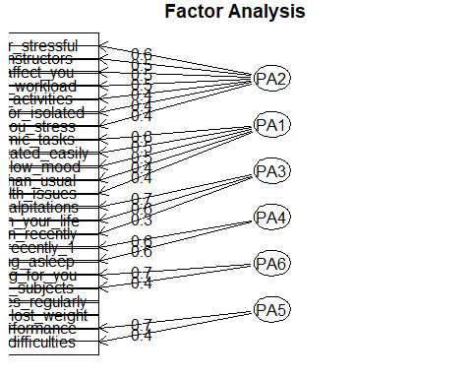

7. Reevaluate Reliability - cross check
factors | raw_alpha
anxiety | 0.57
academic | 0.44
sleep | 0.57
environment | 0.65
depression | 0.65
confidence | 0.48

8. Recalculating Scores for the new subscales /factors in the dataset
Variable | V1
raw_alpha | 0.79
std.alpha | 0.80
G6(smc) | 0.80
average_r | 0.12
S/N | 4.11
ase | 0.01
mean | 3.97
sd | 0.69
median_r | 0.08
[1] 29 8
Variable | n | raw.r | std.r | r.cor | r.drop | mean | sd
anxiety | 843.00 | 0.45 | 0.49 | 0.46 | 0.35 | 8.30 | 2.53
academic | 843.00 | 0.44 | 0.48 | 0.44 | 0.36 | 5.40 | 2.06
sleep | 843.00 | 0.43 | 0.46 | 0.41 | 0.34 | 5.45 | 2.12
environment | 843.00 | 0.67 | 0.63 | 0.60 | 0.50 | 17.50 | 4.91
depression | 843.00 | 0.62 | 0.58 | 0.55 | 0.46 | 13.20 | 4.11
confidence | 843.00 | 0.47 | 0.49 | 0.46 | 0.39 | 5.01 | 2.06

9. Score Distribution
Evalutating normality of the dataset. According to the QQ plot, the data seems normal, following the straight line through the origin, there is slight deviation on the tails.
The histogram however, shows there are some outliers.
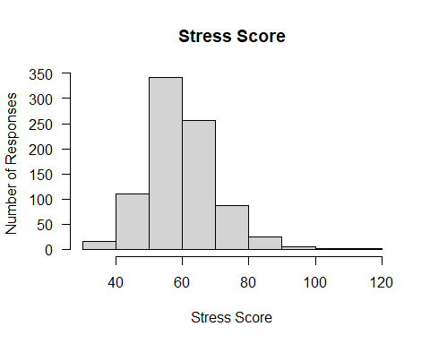
Shapiro-Wilk normality test
data: data_clean3$score
W = 0.97347, p-value = 2.954e-11
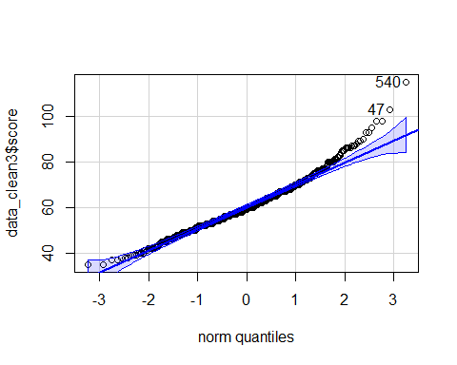
[1] 540 47
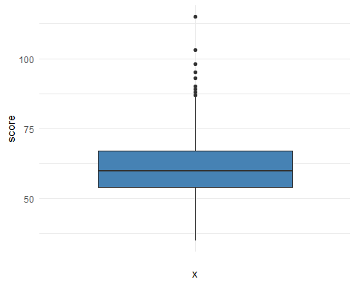

10. Score Distribution - Extreme outlier removal
score 115 shows an extreme outlier which was removed
score | is.outlier | is.extreme
103 | true | false
87 | true | false
98 | true | false
87 | true | false
89 | true | false
90 | true | false
89 | true | false
95 | true | false
93 | true | false
115 | true | true
93 | true | false
98 | true | false
87 | true | false
88 | true | false
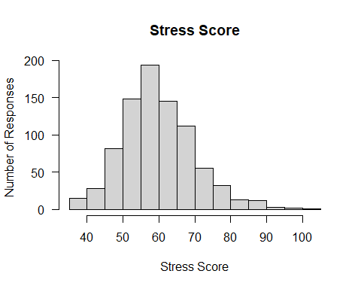
Shapiro-Wilk normality test
data: data_clean4$score
W = 0.98023, p-value = 2.958e-09
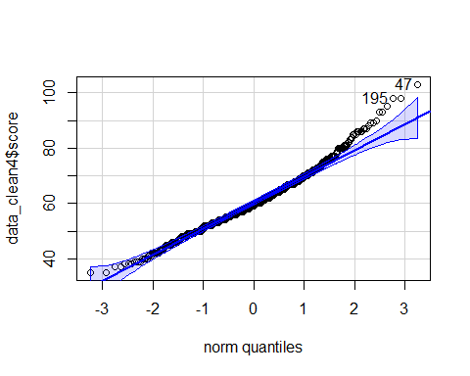
[1] 47 195

11. Linear Regression - Satisfaction Score
We fitted a linear model (estimated using OLS) to predict score with
gender_recode, stress_type, anxiety, academic, sleep, environment, depression,
confidence and age_cleaned (formula: score ~ gender_recode + stress_type +
anxiety + academic + sleep + environment + depression + confidence +
age_cleaned). The model explains a statistically significant and substantial
proportion of variance (R2 = 0.97, F(10, 831) = 3067.42, p < .001, adj. R2 =
0.97). The model's intercept, corresponding to gender_recode = Female,
stress_type = Negative Stress, anxiety = 0, academic = 0, sleep = 0,
environment = 0, depression = 0, confidence = 0 and age_cleaned = 0, is at 6.24
(95% CI [4.86, 7.62], t(831) = 8.87, p < .001). Within this model:
- The effect of gender recode [Male] is statistically non-significant and
negative (beta = -3.05e-03, 95% CI [-0.24, 0.23], t(831) = -0.03, p = 0.980;
Std. beta = -3.02e-04, 95% CI [-0.02, 0.02])
- The effect of stress type [No Stress] is statistically significant and
negative (beta = -2.47, 95% CI [-3.48, -1.46], t(831) = -4.80, p < .001; Std.
beta = -0.24, 95% CI [-0.34, -0.14])
- The effect of stress type [Positive Stress] is statistically significant and
negative (beta = -1.08, 95% CI [-1.79, -0.37], t(831) = -2.98, p = 0.003; Std.
beta = -0.11, 95% CI [-0.18, -0.04])
- The effect of anxiety is statistically significant and positive (beta = 1.05,
95% CI [1.00, 1.10], t(831) = 42.76, p < .001; Std. beta = 0.26, 95% CI [0.25,
0.27])
- The effect of academic is statistically significant and positive (beta =
1.19, 95% CI [1.13, 1.24], t(831) = 40.10, p < .001; Std. beta = 0.24, 95% CI
[0.23, 0.25])
- The effect of sleep is statistically significant and positive (beta = 1.00,
95% CI [0.94, 1.05], t(831) = 33.97, p < .001; Std. beta = 0.21, 95% CI [0.20,
0.22])
- The effect of environment is statistically significant and positive (beta =
0.98, 95% CI [0.96, 1.01], t(831) = 75.75, p < .001; Std. beta = 0.47, 95% CI
[0.46, 0.49])
- The effect of depression is statistically significant and positive (beta =
0.96, 95% CI [0.93, 0.99], t(831) = 62.35, p < .001; Std. beta = 0.39, 95% CI
[0.38, 0.40])
- The effect of confidence is statistically significant and positive (beta =
0.99, 95% CI [0.93, 1.05], t(831) = 33.36, p < .001; Std. beta = 0.20, 95% CI
[0.19, 0.21])
- The effect of age cleaned is statistically non-significant and positive (beta
= 3.84e-03, 95% CI [-0.02, 0.02], t(831) = 0.36, p = 0.716; Std. beta =
2.06e-03, 95% CI [-9.06e-03, 0.01])
Standardized parameters were obtained by fitting the model on a standardized
version of the dataset. 95% Confidence Intervals (CIs) and p-values were
computed using a Wald t-distribution approximation.

12. Assumptions
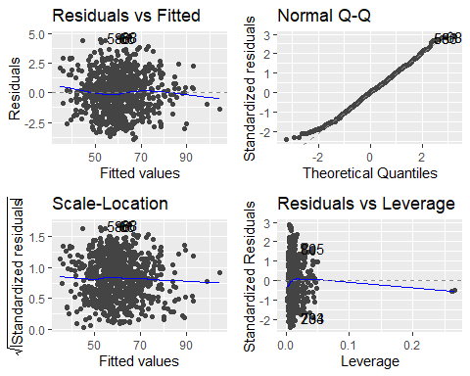

13. Reporting Beta table
Characteristic | Beta | 95% CI | p-value
gender_recode
Female | — | —
Male | -0.003 | -0.238, 0.232 | 0.980
stress_type
Negative Stress | — | —
No Stress | -2.470 | -3.481, -1.460 | <0.001
Positive Stress | -1.080 | -1.793, -0.368 | 0.003
anxiety | 1.050 | 1.002, 1.099 | <0.001
academic | 1.186 | 1.128, 1.244 | <0.001
sleep | 0.997 | 0.939, 1.054 | <0.001
environment | 0.982 | 0.956, 1.007 | <0.001
depression | 0.961 | 0.931, 0.991 | <0.001
confidence | 0.991 | 0.932, 1.049 | <0.001
age_cleaned | 0.004 | -0.017, 0.025 | 0.716
Abbreviation: CI = Confidence Interval

14. Reporting ANOVA Table
Variable | Sum of Squares | df | F statistic | p-value
gender_recode | 0.002 | 1 | 0.001 | 0.980
stress_type | 71.743 | 2 | 13.179 | 0.000
anxiety | 4,977.848 | 1 | 1,828.843 | 0.000
academic | 4,376.732 | 1 | 1,607.995 | 0.000
sleep | 3,141.644 | 1 | 1,154.228 | 0.000
environment | 15,617.187 | 1 | 5,737.696 | 0.000
depression | 10,580.653 | 1 | 3,887.292 | 0.000
confidence | 3,029.659 | 1 | 1,113.085 | 0.000
age_cleaned | 0.361 | 1 | 0.132 | 0.716
Residuals | 2,261.863 | 831
The ANOVA suggests that:
- The main effect of gender_recode is statistically not significant and very
small (F(1, 831) = 6.50e-04, p = 0.980; Eta2 (partial) = 7.82e-07, 95% CI
[0.00, 1.00])
- The main effect of stress_type is statistically significant and small (F(2,
831) = 13.18, p < .001; Eta2 (partial) = 0.03, 95% CI [0.01, 1.00])
- The main effect of anxiety is statistically significant and large (F(1, 831)
= 1828.84, p < .001; Eta2 (partial) = 0.69, 95% CI [0.66, 1.00])
- The main effect of academic is statistically significant and large (F(1, 831)
= 1608.00, p < .001; Eta2 (partial) = 0.66, 95% CI [0.63, 1.00])
- The main effect of sleep is statistically significant and large (F(1, 831) =
1154.23, p < .001; Eta2 (partial) = 0.58, 95% CI [0.55, 1.00])
- The main effect of environment is statistically significant and large (F(1,
831) = 5737.70, p < .001; Eta2 (partial) = 0.87, 95% CI [0.86, 1.00])
- The main effect of depression is statistically significant and large (F(1,
831) = 3887.29, p < .001; Eta2 (partial) = 0.82, 95% CI [0.81, 1.00])
- The main effect of confidence is statistically significant and large (F(1,
831) = 1113.09, p < .001; Eta2 (partial) = 0.57, 95% CI [0.54, 1.00])
- The main effect of age_cleaned is statistically not significant and very
small (F(1, 831) = 0.13, p = 0.716; Eta2 (partial) = 1.59e-04, 95% CI [0.00,
1.00])
Effect sizes were labelled following Field's (2013) recommendations.

15. R package References
Analyses were conducted using the R Statistical language (version 4.6.0; R Core
Team, 2026) on Windows 11 x64 (build 26300), using the packages GPArotation
(version 2026.6.1; Bernaards CA, Jennrich RI, 2005), janitor (version 2.2.1;
Firke S, 2024), car (version 3.1.5; Fox J, Weisberg S, 2019), carData (version
3.0.6; Fox J et al., 2026), flextable (version 0.9.12; Gohel D, Skintzos P,
2026), lubridate (version 1.9.5; Grolemund G, Wickham H, 2011), dslabs (version
0.9.1; Irizarry RA, Gill A, 2025), ggpubr (version 1.0.0; Kassambara A, 2026),
rstatix (version 1.0.0; Kassambara A, 2026), report (version 0.6.4; Makowski D
et al., 2023), tibble (version 3.3.1; Müller K, Wickham H, 2026), broom
(version 1.0.13; Robinson D et al., 2026), gtsummary (version 2.5.1; Sjoberg D
et al., 2021), ggfortify (version 0.4.19; Tang Y et al., 2016), skimr (version
2.2.2; Waring E et al., 2026), ggplot2 (version 4.0.3; Wickham H, 2016),
forcats (version 1.0.1; Wickham H, 2025), stringr (version 1.6.0; Wickham H,
2025), tidyverse (version 2.0.0; Wickham H et al., 2019), dplyr (version 1.2.1;
Wickham H et al., 2026), purrr (version 1.2.2; Wickham H, Henry L, 2026), readr
(version 2.2.0; Wickham H et al., 2026), scales (version 1.4.0; Wickham H et
al., 2025), tidyr (version 1.3.2; Wickham H et al., 2025), psych (version
2.6.5; William Revelle, 2026), knitr (version 1.51; Xie Y, 2025) and kableExtra
(version 1.4.0; Zhu H, 2024).
References
----------
- Bernaards CA, Jennrich RI (2005). "Gradient Projection Algorithms and
Software for Arbitrary Rotation Criteria in Factor Analysis." _Educational and
Psychological Measurement_, *65*, 676-696. doi:10.1177/0013164404272507
<https://doi.org/10.1177/0013164404272507>.
- Firke S (2024). _janitor: Simple Tools for Examining and Cleaning Dirty
Data_. doi:10.32614/CRAN.package.janitor
<https://doi.org/10.32614/CRAN.package.janitor>. R package version 2.2.1,
<https://CRAN.R-project.org/package=janitor>.
- Fox J, Weisberg S (2019). _An R Companion to Applied Regression_, Third
edition. Sage, Thousand Oaks CA. <https://www.john-fox.ca/Companion/>.
- Fox J, Weisberg S, Price B (2026). _carData: Companion to Applied Regression
Data Sets_. doi:10.32614/CRAN.package.carData
<https://doi.org/10.32614/CRAN.package.carData>. R package version 3.0-6,
<https://CRAN.R-project.org/package=carData>.
- Gohel D, Skintzos P (2026). _flextable: Functions for Tabular Reporting_.
doi:10.32614/CRAN.package.flextable
<https://doi.org/10.32614/CRAN.package.flextable>. R package version 0.9.12,
<https://CRAN.R-project.org/package=flextable>.
- Grolemund G, Wickham H (2011). "Dates and Times Made Easy with lubridate."
_Journal of Statistical Software_, *40*(3), 1-25.
<https://www.jstatsoft.org/v40/i03/>.
- Irizarry RA, Gill A (2025). _dslabs: Data Science Labs_.
doi:10.32614/CRAN.package.dslabs
<https://doi.org/10.32614/CRAN.package.dslabs>. R package version 0.9.1,
<https://CRAN.R-project.org/package=dslabs>.
- Kassambara A (2026). _ggpubr: 'ggplot2' Based Publication Ready Plots_. R
package version 0.6.3.999, <https://CRAN.R-project.org/package=ggpubr>.
- Kassambara A (2026). _rstatix: Pipe-Friendly Framework for Basic Statistical
Tests_. doi:10.32614/CRAN.package.rstatix
<https://doi.org/10.32614/CRAN.package.rstatix>. R package version 1.0.0,
<https://CRAN.R-project.org/package=rstatix>.
- Makowski D, Lüdecke D, Patil I, Thériault R, Ben-Shachar M, Wiernik B (2023).
"Automated Results Reporting as a Practical Tool to Improve Reproducibility and
Methodological Best Practices Adoption." _CRAN_.
doi:10.32614/CRAN.package.report
<https://doi.org/10.32614/CRAN.package.report>.
<https://easystats.github.io/report/>.
- Müller K, Wickham H (2026). _tibble: Simple Data Frames_.
doi:10.32614/CRAN.package.tibble
<https://doi.org/10.32614/CRAN.package.tibble>. R package version 3.3.1,
<https://CRAN.R-project.org/package=tibble>.
- R Core Team (2026). _R: A Language and Environment for Statistical
Computing_. R Foundation for Statistical Computing, Vienna, Austria.
doi:10.32614/R.manuals <https://doi.org/10.32614/R.manuals>.
<https://www.R-project.org/>.
- Robinson D, Hayes A, Couch S, Hvitfeldt E (2026). _broom: Convert Statistical
Objects into Tidy Tibbles_. doi:10.32614/CRAN.package.broom
<https://doi.org/10.32614/CRAN.package.broom>. R package version 1.0.13,
<https://CRAN.R-project.org/package=broom>.
- Sjoberg D, Whiting K, Curry M, Lavery J, Larmarange J (2021). "Reproducible
Summary Tables with the gtsummary Package." _The R Journal_, *13*, 570-580.
doi:10.32614/RJ-2021-053 <https://doi.org/10.32614/RJ-2021-053>.
<https://doi.org/10.32614/RJ-2021-053>.
- Tang Y, Horikoshi M, Li W (2016). "ggfortify: Unified Interface to Visualize
Statistical Result of Popular R Packages." _The R Journal_, *8*(2), 474-485.
doi:10.32614/RJ-2016-060 <https://doi.org/10.32614/RJ-2016-060>.
<https://doi.org/10.32614/RJ-2016-060>. Horikoshi M, Tang Y (2018). _ggfortify:
Data Visualization Tools for Statistical Analysis Results_.
<https://CRAN.R-project.org/package=ggfortify>.
- Waring E, Quinn M, McNamara A, Arino de la Rubia E, Zhu H, Ellis S (2026).
_skimr: Compact and Flexible Summaries of Data_.
doi:10.32614/CRAN.package.skimr <https://doi.org/10.32614/CRAN.package.skimr>.
R package version 2.2.2, <https://CRAN.R-project.org/package=skimr>.
- Wickham H (2016). _ggplot2: Elegant Graphics for Data Analysis_.
Springer-Verlag New York. ISBN 978-3-319-24277-4.
<https://ggplot2.tidyverse.org>.
- Wickham H (2025). _forcats: Tools for Working with Categorical Variables
(Factors)_. doi:10.32614/CRAN.package.forcats
<https://doi.org/10.32614/CRAN.package.forcats>. R package version 1.0.1,
<https://CRAN.R-project.org/package=forcats>.
- Wickham H (2025). _stringr: Simple, Consistent Wrappers for Common String
Operations_. doi:10.32614/CRAN.package.stringr
<https://doi.org/10.32614/CRAN.package.stringr>. R package version 1.6.0,
<https://CRAN.R-project.org/package=stringr>.
- Wickham H, Averick M, Bryan J, Chang W, McGowan LD, François R, Grolemund G,
Hayes A, Henry L, Hester J, Kuhn M, Pedersen TL, Miller E, Bache SM, Müller K,
Ooms J, Robinson D, Seidel DP, Spinu V, Takahashi K, Vaughan D, Wilke C, Woo K,
Yutani H (2019). "Welcome to the tidyverse." _Journal of Open Source Software_,
*4*(43), 1686. doi:10.21105/joss.01686 <https://doi.org/10.21105/joss.01686>.
- Wickham H, François R, Henry L, Müller K, Vaughan D (2026). _dplyr: A Grammar
of Data Manipulation_. doi:10.32614/CRAN.package.dplyr
<https://doi.org/10.32614/CRAN.package.dplyr>. R package version 1.2.1,
<https://CRAN.R-project.org/package=dplyr>.
- Wickham H, Henry L (2026). _purrr: Functional Programming Tools_.
doi:10.32614/CRAN.package.purrr <https://doi.org/10.32614/CRAN.package.purrr>.
R package version 1.2.2, <https://CRAN.R-project.org/package=purrr>.
- Wickham H, Hester J, Bryan J (2026). _readr: Read Rectangular Text Data_.
doi:10.32614/CRAN.package.readr <https://doi.org/10.32614/CRAN.package.readr>.
R package version 2.2.0, <https://CRAN.R-project.org/package=readr>.
- Wickham H, Pedersen T, Seidel D (2025). _scales: Scale Functions for
Visualization_. doi:10.32614/CRAN.package.scales
<https://doi.org/10.32614/CRAN.package.scales>. R package version 1.4.0,
<https://CRAN.R-project.org/package=scales>.
- Wickham H, Vaughan D, Girlich M (2025). _tidyr: Tidy Messy Data_.
doi:10.32614/CRAN.package.tidyr <https://doi.org/10.32614/CRAN.package.tidyr>.
R package version 1.3.2, <https://CRAN.R-project.org/package=tidyr>.
- William Revelle (2026). _psych: Procedures for Psychological, Psychometric,
and Personality Research_. Northwestern University, Evanston, Illinois. R
package version 2.6.4, <https://CRAN.R-project.org/package=psych>.
- Xie Y (2025). _knitr: A General-Purpose Package for Dynamic Report Generation
in R_. R package version 1.51, <https://yihui.org/knitr/>. Xie Y (2015).
_Dynamic Documents with R and knitr_, 2nd edition. Chapman and Hall/CRC, Boca
Raton, Florida. ISBN 978-1498716963, <https://yihui.org/knitr/>. Xie Y (2014).
"knitr: A Comprehensive Tool for Reproducible Research in R." In Stodden V,
Leisch F, Peng RD (eds.), _Implementing Reproducible Computational Research_.
Chapman and Hall/CRC. ISBN 978-1466561595.
- Zhu H (2024). _kableExtra: Construct Complex Table with 'kable' and Pipe
Syntax_. doi:10.32614/CRAN.package.kableExtra
<https://doi.org/10.32614/CRAN.package.kableExtra>. R package version 1.4.0,
<https://CRAN.R-project.org/package=kableExtra>.

16. References
- Stress and Well-being Data of College Students [Internet]. [cited 2026 Oct 3]. Available from: https://www.kaggle.com/datasets/ashutoshsingh22102/stress-and-well-being-data-of-college-students
- Machine Learning Algorithms for Detecting Mental Stress in College Students | IEEE Conference Publication | IEEE Xplore [Internet]. [cited 2026 Oct 3]. Available from: https://ieeexplore.ieee.org/abstract/document/10544243
- Optimizing Well-Being: Unveiling Eustress and Distress through Machine Learning | IEEE Conference Publication | IEEE Xplore [Internet]. [cited 2026 Oct 3]. Available from: https://ieeexplore.ieee.org/abstract/document/10544592
- Ovi MSI, Hossain J, Rahi MRA, Akter F. Protecting Student Mental Health with a Context-Aware Machine Learning Framework for Stress Monitoring [Internet]. arXiv; 2025 [cited 2026 Oct 3]. Available from: http://arxiv.org/abs/2508.01105 doi:10.48550/arXiv.2508.01105
- Student Stress Monitoring Datasets [Internet]. [cited 2026 Oct 3]. Available from: https://www.kaggle.com/datasets/mdsultanulislamovi/student-stress-monitoring-datasets
- Brown S. Likert Scale Examples for Surveys.
- 8 Cleaning data and core functions – The Epidemiologist R Handbook [Internet]. [cited 2026 Oct 3]. Available from: https://www.epirhandbook.com/en/new_pages/cleaning.html#column-names
- RPubs - A Primer on Factor Analysis in Resear using Reproducible R Software [Internet]. [cited 2026 Oct 3]. Available from: https://rpubs.com/Geesaale/1064415
- EBSCO [Internet]. [cited 2026 Oct 3]. Cronbach’s alpha | Science | Research Starters | EBSCOhost. Available from: https://www.ebsco.com/
- 17 Descriptive tables – The Epidemiologist R Handbook [Internet]. [cited 2026 Oct 3]. Available from: https://www.epirhandbook.com/en/new_pages/tables_descriptive.html#dplyr-package
- Stats and R [Internet]. [cited 2026 Oct 3]. ANOVA in R. Available from: https://statsandr.com/blog/anova-in-r/
- Comparison tests/methods available — tests [Internet]. [cited 2026 Oct 3]. Available from: https://www.danieldsjoberg.com/gtsummary/reference/tests.html
- neversaint. How to change legend title in ggplot [Forum post]. Stack Overflow [Internet]. 2022 [cited 2026 Oct 3]. Available from: https://stackoverflow.com/q/14622421
- MASH. Guides: MASH : Maths and Stats Help: Cronbach’s Alpha (R) [Internet]. [cited 2026 Oct 3]. Available from: https://guides.library.lincoln.ac.uk/mash/cronbachs_alpha_R

